%matplotlib inline

import matplotlib.pyplot as plt

import numpy as np

X = np.array(

[[7,8],[12,20],[17,19],[26,15],[32,37],[87,75],[73,85], [62,80],[73,60],[87,96],])

labels = range(1, 11)

plt.figure(figsize = (10, 7))

plt.subplots_adjust(bottom = 0.1)

plt.scatter(X[:,0],X[:,1], label = 'True Position')

for label, x, y in zip(labels, X[:, 0], X[:, 1]):

plt.annotate(

label,xy = (x, y), xytext = (-3, 3),

textcoords = 'offset points', ha = 'right', va = 'bottom')

plt.show()

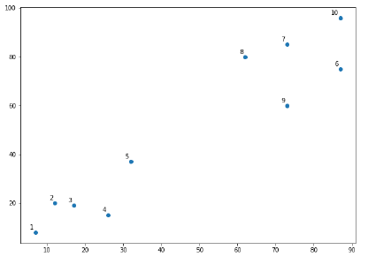

Con este grafico parece que hay varios clusters, usamos un dendrograma para aclarar

from scipy.cluster.hierarchy import dendrogram, linkage

from matplotlib import pyplot as plt

linked = linkage(X, 'single')

labelList = range(1, 11)

plt.figure(figsize = (10, 7))

dendrogram(linked, orientation = 'top',labels = labelList,

distance_sort ='descending',show_leaf_counts = True)

plt.show()

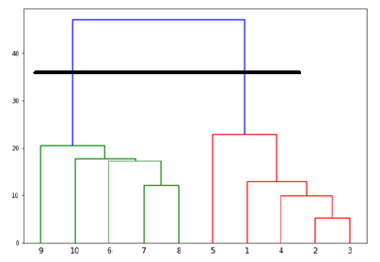

El dendrograma nos dice

* Azul- abarca todo los puntos
* Verde – un cluster
* Rojo – otro cluster